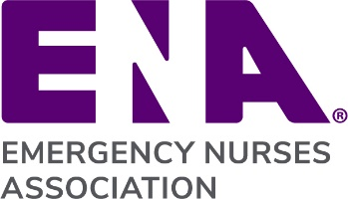
{Replace ENA Logo with State Council or Chapter Logo}
{Year} Budget Narrative
{State Council or Chapter name}

Major Initiatives

Initiative a
Initiative b

(Example:
Launched new website this year)

Key Assumptions

Assumption 1
Assumption 2

(Example:
Revenue is based on assessments from National remaining flat)

Significant Variances

Line Item – Increase or Decrease
Explanation:

Line Item – Increase or Decrease
Explanation:

Line Item – Increase or Decrease
Explanation:

(Example:
Conference Stipend Expense – Increase
Explanation: Budgeted for 10 attendees, but decided to increase to 15 attendees)

If Deficit Budget – Provide Explanation

Explanation:

(Example:
Explanation: Invested in one-time web developer expense to support redesign of website. Will not incur this additional expense again next year.)

